Khaled Saad Almatrafy
Master Level in Big Data Analysis
College of Computer Science and Engineering
Taibah University
MSIS-822 Advanced Data Analytic Techniques
Honorable Prof. Mohammad ALsarim
December 2025

Detection of AI-Generated Arabic Text:
A Data Mining Approach

Abstract
When Prof. Alsarim share his vision with the Class of M4 regarding this 822 Course, along the way he interpret the significant aspect of this project regarding our development in the Big Data Analysis. When I first start working on the project, it felt like I am in the middle of no-where. Now after finishing it, the degree I've reached so far make me proud of all the hard work and effort I managed to achieve. The deeper we dive the wider it gets.

Introduction:
Detection of AI-Generated Media has storm the public every day browsing among social media, which significantly mean that the digital work-force in both side, Generating and Detection contexts achieving massive results, yet the NLP are reaching OK level regarding English Language, Thus more work needed to reach an OK level in the ladder of Arabic Language NLP. This project aim to achieve a proud effort regarding this subject.

Dataset Description:
As directed by Prof. AL-sarim this project rely on
KFUPM-JRCAI/arabic-generated-abstracts Available on Hugging Face:
(https://huggingface.co/datasets/KFUPM-JRCAI/arabic-generated-abstracts)

This is publicly available Arabic machine generated text dataset hosted on Hugging Face . it contains pairs of academic abstract in Arabic, part is human presented under the label Original abstract, and part is AI, generated by many language models which are:
- Allam_generated_abstract
- Jais_generated_abstract
- Llama_generated_abstract
- Open_ai_generated_abstract

- Total samples: 41,940
- Features:
  - abstract_text – the raw abstract
  - source_split – originating data source identifier
  - generated_by – human or model name
  - label – 0 for human, 1 for AI
Additional Remark:
fun facts, to interpret what is name stands for:
ALLAM : Arabic Language Large Model
LLAM: Large Language Model
JAIS: from the mountain in UAE named Jais.

PHASE 1


https://github.com/khaleds1341
https://github.com/khaleds1341/project_822

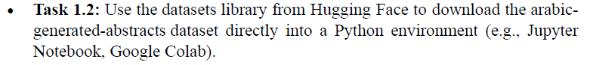

from datasets import load_dataset
import pandas as pd

# Load the dataset
dataset = load_dataset("KFUPM-JRCAI/arabic-generated-abstracts")

Checking for Noise:

At the top of the code< I've listed almost all pipeline needed to run the code
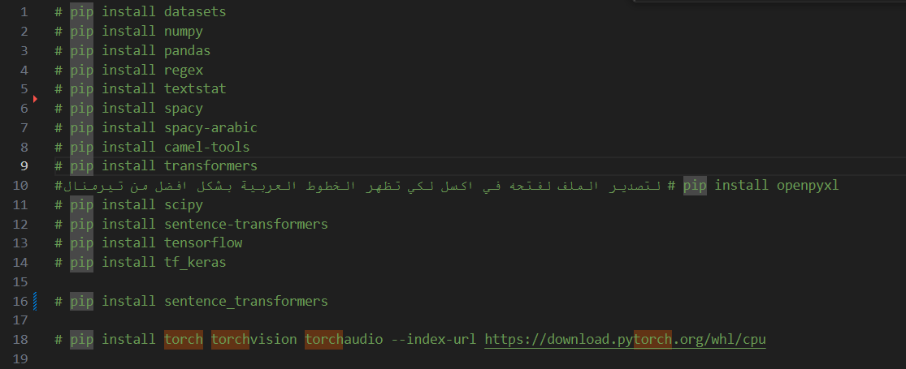

PHASE 2

Preprocessing:
Arabic Language is the richest language, many word might have the same shape but due to a simple symbol the meaning and spilling might chang; thus there are
- Diacritics (Tashkeel ًٌَُّ)
- Long Vowel (Madd ـا ـيـ ـوـ)
And as many languages
- Punctuation Marks.

In order to make the dataset ready for mining, the dataset had been preprocessed as:
- Remove Diacritics (Tashkeel)
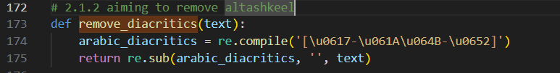

- Normalize: the first letter in Arabic is " ALEF" it has 3 pronounciation based on three sumbol it has called " "HAMZA", [ أَ , إ , أُ ] removing HAMZA is an example of how normalize used.
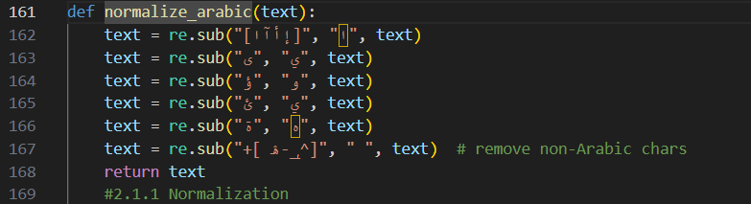
- Stopwords such as full stop or question mark or !
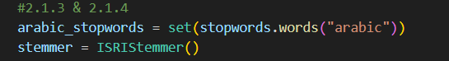

- Additional remark:::
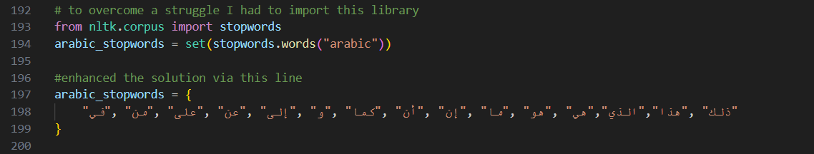

VISUALIZATION

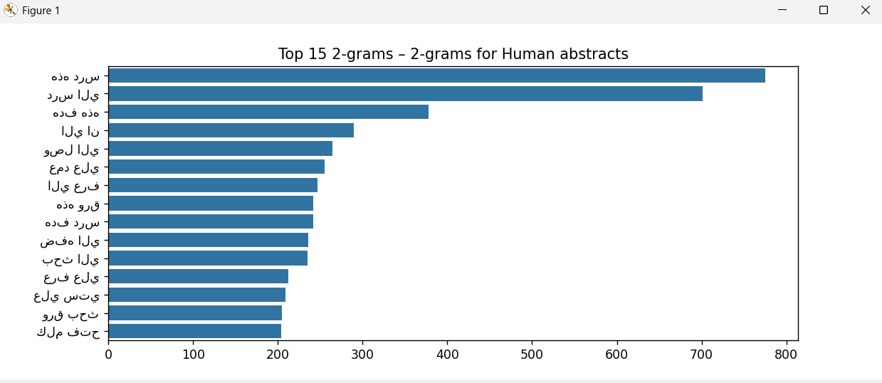

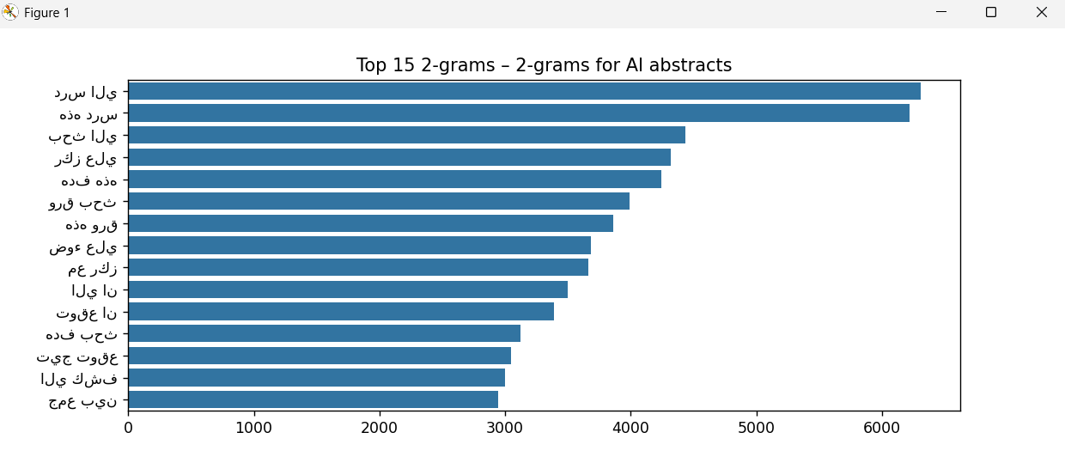

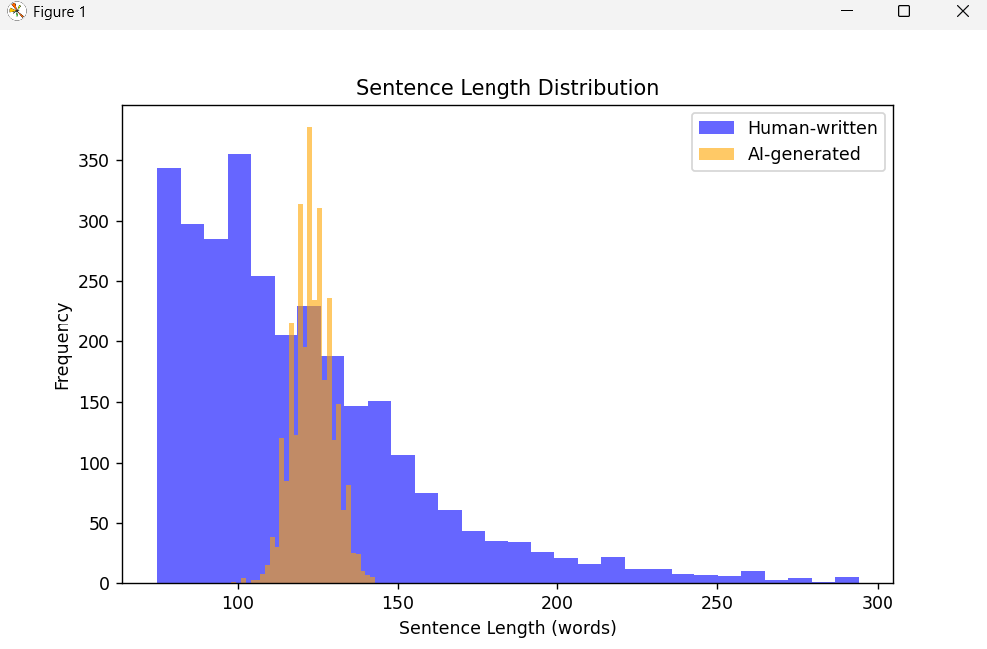
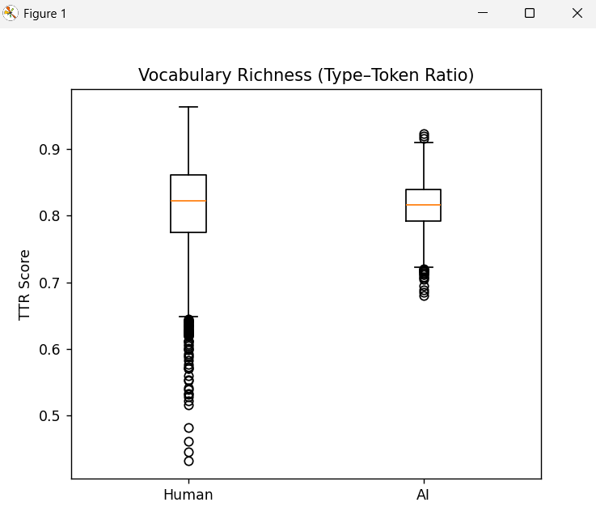

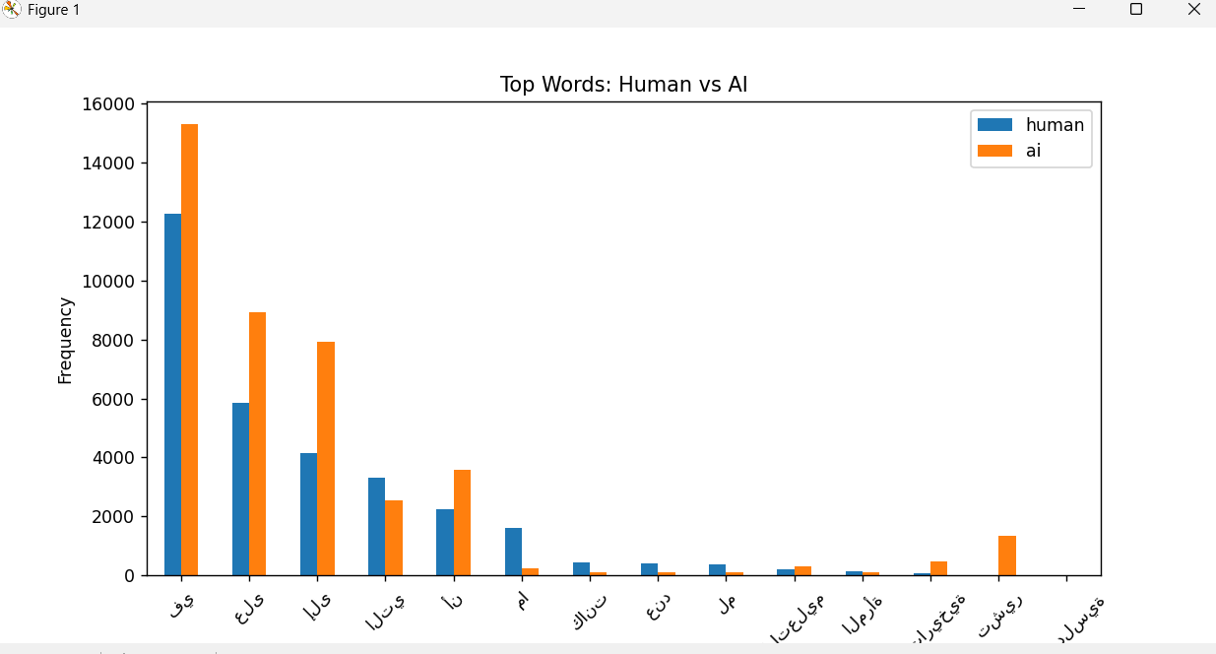

- Function Words removal/comparison
- Vocabulary Richness
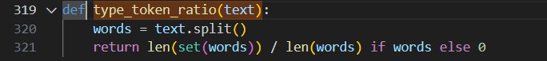

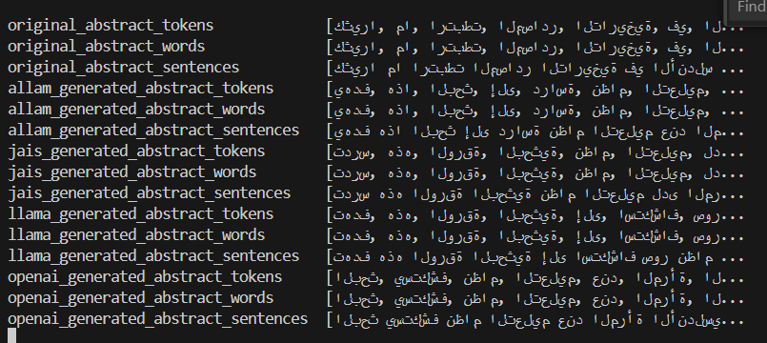

TOKENs: smallest units after splitting text into word and punctuation
WORDs: cleaned of preprocessed tokens
SENTENCEs: text split into sentences

PHASE 3
Functions used based on Prof. ALsarim direction start from number 5
Added by 23 number of students in M4 class
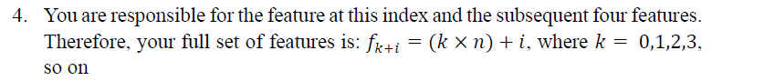
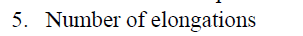
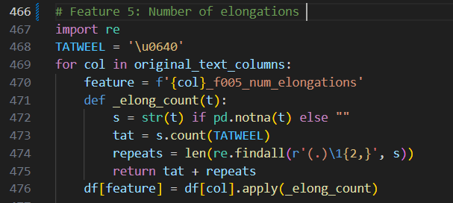

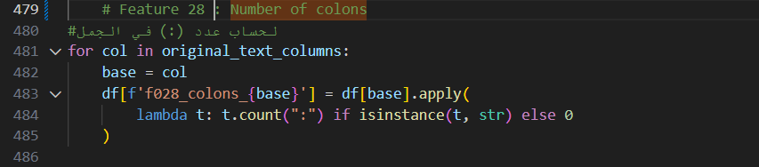
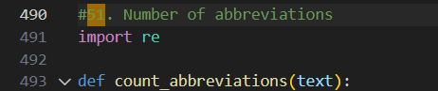
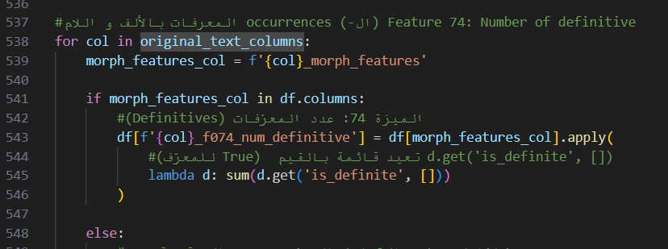

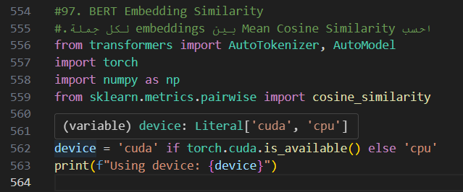
Transformer: library that contain BERT and many AI Language models
When I run the code and reach BERT Embedding… since my computer does not has GPU, running the code was heavy on CPU, it took about more than 20 minutes.

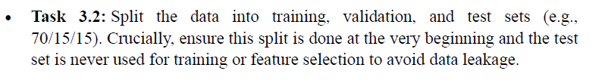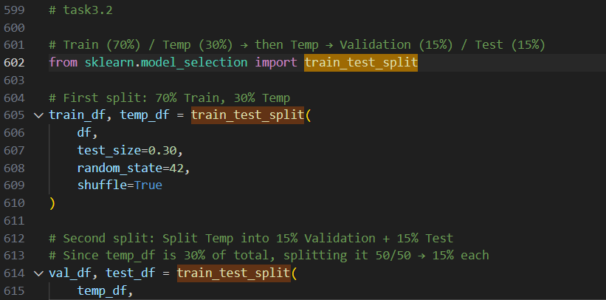

PHASE 4

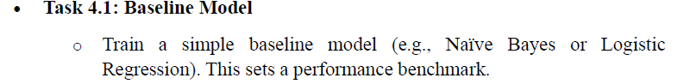
Necessity preparation needed to be able to conduct task 4.1.
Libraries:
Data handling
- Pandas: to manage dataframes
- numpy: numeric computation
- os

text preprocessing and NLP
- re and regex as re2: for Arabic aware regex operation
- ntlk for stopwords and stemming(ISRIStemmer)
- datasets
feature extraction
- TF-IDF VECTORIZATION
- SCIPY to handle numeric + sparse TF-IDF features
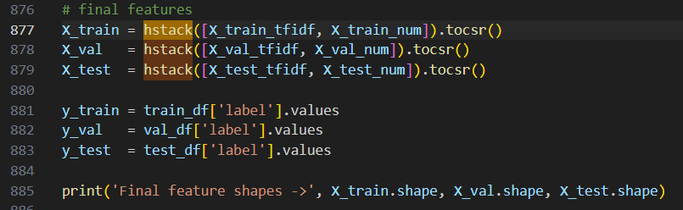
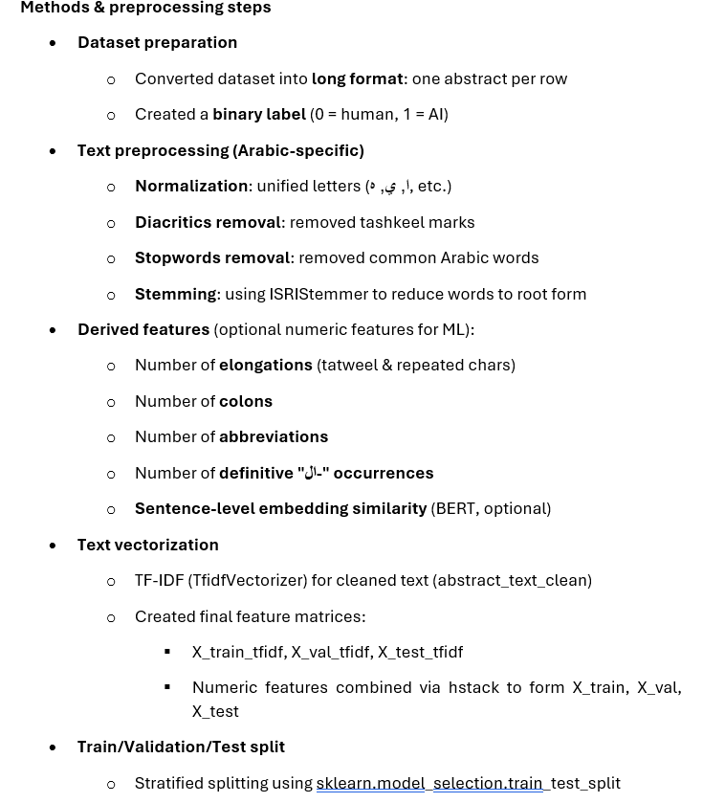

Snippet
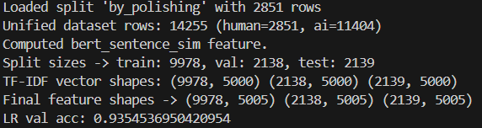

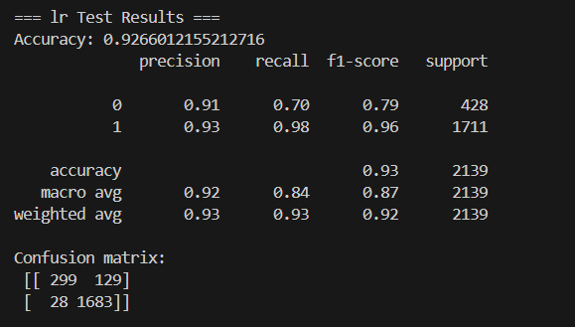
Test Evaluation for Logistic Regression Model
Class 0 = Human written
Class 1 = AI generated
Metric | Class 0 | Class 1 | Notes
Precision | 0.91 | 0.93 | How many predicted as class x are correct
Recall | 0.70 | 0.98 | How many actual class x were correctly predicted
F1-score | 0.79 | 0.96 | Mean of P & R
Support | 428 | 1711 | Number of samples
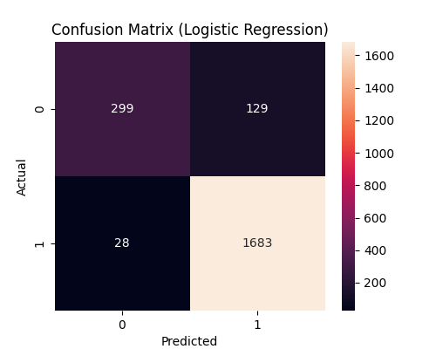

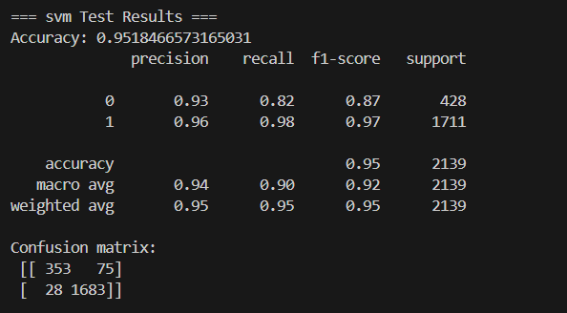
Test Evaluation for Support Vector Machine Model
Class 0 = Human written
Class 1 = AI generated
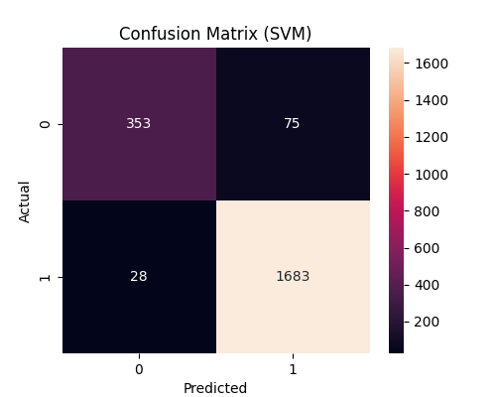
Metric | Class 0 | Class 1 | Notes
Precision | 0.93 | 0.96 | How many predicted as class x are correct
Recall | 0.82 | 0.98 | How many actual class x were correctly predicted
F1-score | 0.87 | 0.97 | Mean of P & R
Support | 428 | 1711 | Number of samples
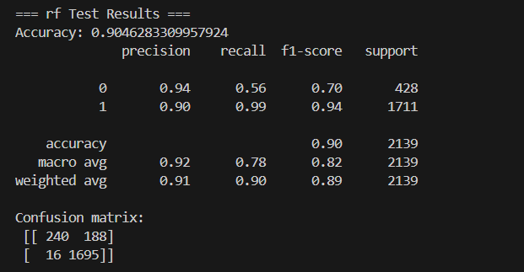
Test Evaluation for Random Forrest Model
Class 0 = Human written
Class 1 = AI generated
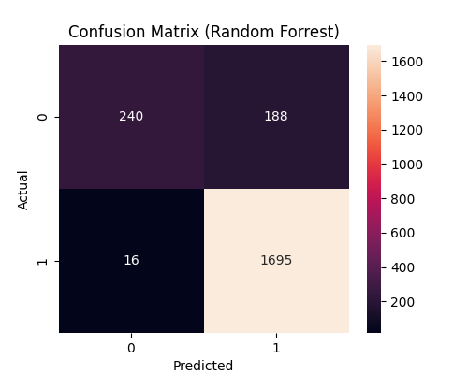
Metric | Class 0 | Class 1 | Notes
Precision | 0.94 | 0.90 | How many predicted as class x are correct
Recall | 0.56 | 0.99 | How many actual class x were correctly predicted
F1-score | 0.70 | 0.94 | Mean of P & R
Support | 428 | 1711 | Number of samples
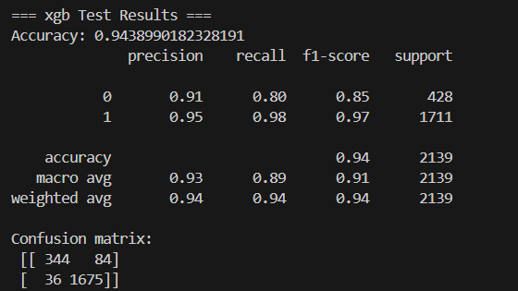
Test Evaluation for Genetic Programing XGP Model
Class 0 = Human written
Class 1 = AI generated
Metric | Class 0 | Class 1 | Notes
Precision | 0.91 | 0.95 | How many predicted as class x are correct
Recall | 0.80 | 0.98 | How many actual class x were correctly predicted
F1-score | 0.85 | 0.97 | Mean of P & R
Support | 428 | 1711 | Number of samples
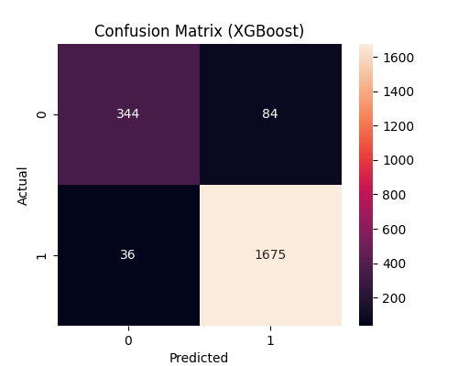

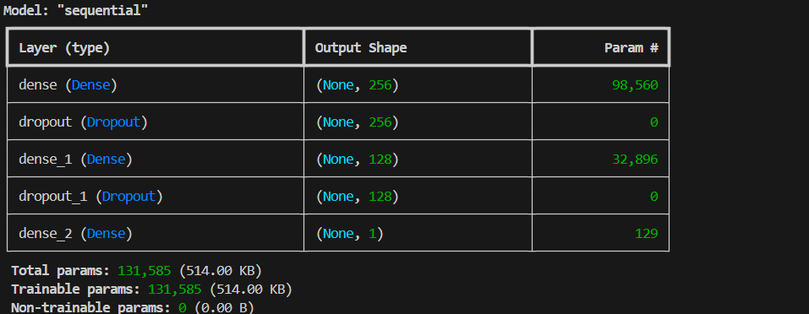
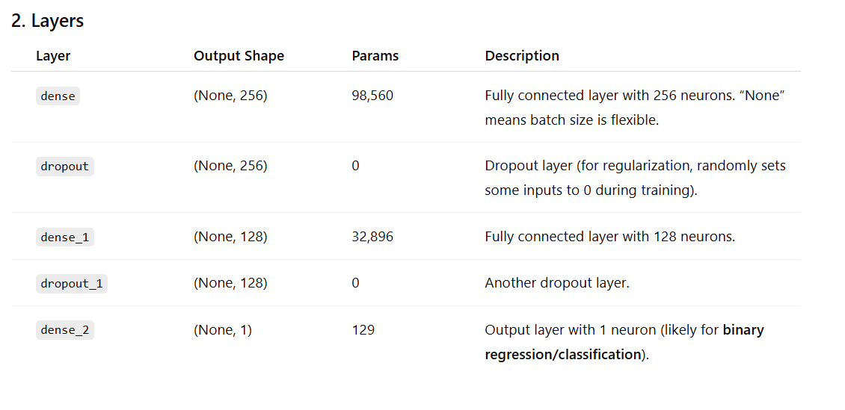
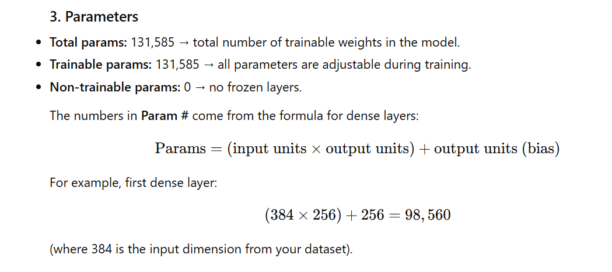
The Feedforward Neural Network (FFNN) was trained for 5 epochs using the training dataset, and performance was evaluated on a separate validation set after each epoch.

In Epoch 1, the model has achieved a training accuracy of (79.83%) with a loss of (47.50%), while the validation accuracy was (80.03%) and validation loss (44%).

In Epoch 2, the training accuracy slightly increased to (80%) and the loss decreased to (44.13%), with validation accuracy improving to (81.34%) and validation loss at (44.18%).

Epoch 3 showed further improvement in training accuracy (80.53%) and a lower loss (42.84%), while validation accuracy remained high at (80.87%) and validation loss decreased to (40.39%).

During Epoch 4, the training accuracy reached (80.61%) with a loss of (41. 59%) and the validation metrics were (80.22%) accuracy and 40.82%) loss.

Finally, in Epoch 5, the model achieved its best performance with (81.42%) training accuracy and (40.80%) loss, while the validation accuracy was (82.69%) and validation loss (39.78%), indicating that the model learned effectively over successive epochs with no significant overfitting.

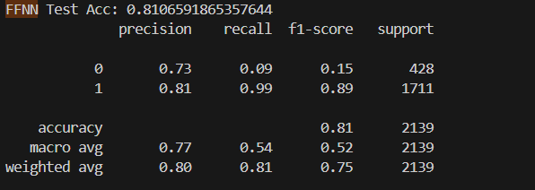
Test Evaluation for Feedforward Neural Network (FFNN) Model
Class 0 = Human written
Class 1 = AI generated
Metric | Class 0 | Class 1 | Notes
Precision | 0.73 | 0.81 | How many predicted as class x are correct
Recall | 0.09 | 0.99 | How many actual class x were correctly predicted
F1-score | 0.15 | 0.89 | Mean of P & R
Support | 428 | 1711 | Number of samples

- Additional remark:::
I try so many times to find solution for the shortage of the FFNN code. But this is the best I could've done. I will try to improve my ability repeatedly.

conclusion
Between the five models listed above, SVM has achieved the strongest overall predictive performance, Yet the imbalance in the dataset caused all model to act bias in favor of CLASS 1; which results in low detection of CLASS 0. While the SVM performs best in accuracy and CLASS 0, F1-score, Logistic Regression or SVM may offer more balanced macro-level performance once data imbalance techniques are applied. Future work should focus on balancing methods to improve minority-class detection.

Resources
- https://www.researchgate.net/publication/394621406_Detecting_Machine-Generated_Arabic_Text_Using_AraBERT_and_LSTM_Toward_Trustworthy_NLP_in_Low-Resource_Languages.
- https://arxiv.org/abs/2407.15390
- CHATGPT.com
- Data Mining Concepts and Techniques Third Edition by Jiawei Han er al

